The Interconnection between Language, History, Art, Culture, and Community:
A Study of the Brazil’s African Diaspora
Travel to Brazil: July 1 – 30, 2024

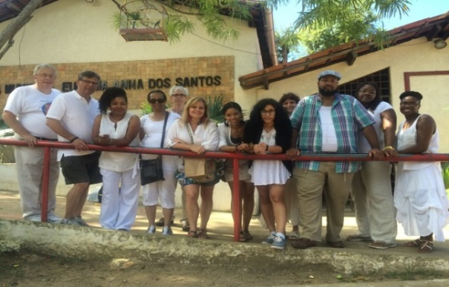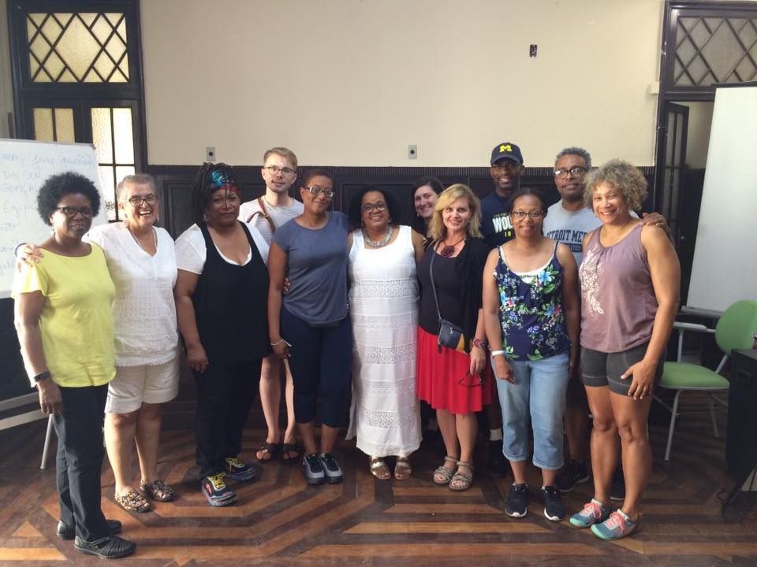

Project Type: Fulbright Hays Curriculum Enhancement Group Project Abroad (GPA)
Grant Award: $131,000 funded by US Department of Education and Bureau of Cultural Affairs
Number of Participants: 14 total, including 2 project directors, 6 faculty/administrators, 6 from K-12*
Priority preference: Humanities faculty, Detroit k-12 teachers

Abstract
This Group Project Abroad (GPA) awarded to the University of Detroit Mercy and Hillsborough Community College will engage several issues relevant to the Afro-Brazilian diaspora, including ethnic and racial affirmation, struggles and triumphs over representation, discourses of harmony and confrontation, and voices of presence and memory. We will approach these topics from the perspectives of music, art, literature, architecture, history, folklore, cuisine, religion, dance, and language. Participants will learn about the hierarchal religion of Candomblé and about the poetry of samba. We will explore the intersection of Catholicism with Africanicity in historic and present manifestations, in part, through the icons of folklore. We will trace the history of religious festivals and practices, and learn about prominent authors, filmmakers, artists, and performers who speak to, from, and about the Afro-Brazilian experience. We will study how these works participate in creating memory and representation of strength.
In addition to our diaspora study, we will also spend considerable time immersing ourselves in Portuguese.
Participants will create curriculum projects related to their disciplines and based on their interests that complement learning and help internationalize programs.
See curriculum projects developed by past GPA participants at https://www.udmercy.edu/academics/academic-affairs/fulbright/gpa.php.

Application and eligibility information
If you meet eligibility criteria and decide to apply in earnest, send your
Intent to Apply email to wasnerle@udmercy.edu; slynch@hccfl.edu by October 1, 2023.

Submit your GPA application (all elements) by November 1, 2023.

Title your application submission Fulbright GPA Application 2024.

You are eligible to apply if you fulfill all of the following requirements:
- You are available for ALL pre-departure Saturday sessions (online) March – May 2024, actively participate, and keep your camera on while in session.
- You are available to travel from approximately July 1 to July 31, 2024.
- You teach full time or are an administer in a humanities program in the U.S.
- You are a U.S. permanent resident or a citizen and hold a valid US passport.
- You have not previously received a Fulbright award or participated in a Fulbright GPA.
- You commit to a $1,500 participant cost share plus cost of incidentals while in Brazil.
- You have received all doses of an approved Covid-19 vaccine.
- You are committed to professional development and sharing what you learn with others.
- You work well in groups, collaborate well with others, and meet deadlines.
Additional considerations: The pace and rigor of this program are intensive and require full participation, engagement, and commitment during all phases of programming, especially while in Brazil. At times, the program will require walking on uneven or unpaved surfaces, hilly areas, and forested regions. During the program, we will travel by foot, bus, plane, and boat.
Application requirements: Submit an essay response to each of the three questions below, PLUS include one letter of reference from a supervisor and your updated CV (no more than 3 pages). Please submit the application as one PDF document rather than five separate documents.

Answer each of the essay questions in double space, Times New Roman. Acceptable essays should range between 2-3 pages per response.

(1) Provide a rationale for how this curriculum enhancement project ties to your discipline and how you will share this experience professionally upon return.
(2) Provide a statement of your interest in learning Brazilian Portuguese.
(3) Discuss your intercultural competence, including but not limited to past travel experiences, ability and willingness to travel with others.
(4) Fulbright will not accept any form of bigotry, harassment or discrimination of any kind. Please provide a personal statement of inclusion, anti-racism, anti-discrimination, and anti-harassment.
Please submit your application to Lara Wasner at wasnerle@udmercy.edu and Suzanne Lynch at slynch@hccfl.edu Follow up by email to ensure your application has been received.

We look forward to traveling with you to Brazil in 2024! Here are some highlights
